**Efficiency begins with planning your loads ahead of arrival to a Beltrami County Facility.**

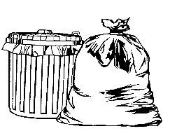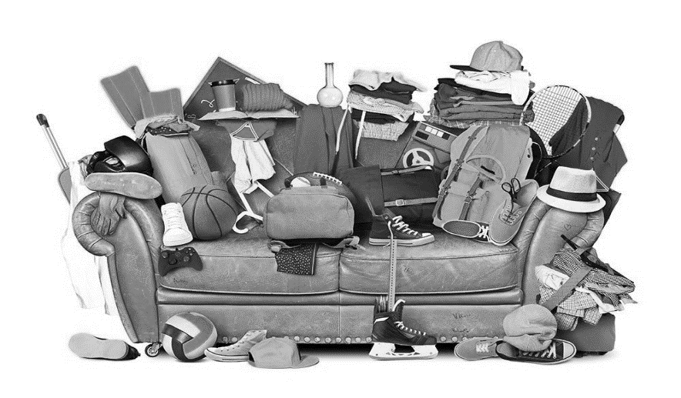

Scrap Metal

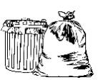



Recycle –

Household Garbage –

Non-Burn –

**Scrap Metal** – **On top of your load if going to the Bemidji Transfer Station since it’s your first stop, and at the bottom of your load at the Blackduck/Kelliher Transfer Station since it’s your last stop.**